Wroclaw, December 12, 2024
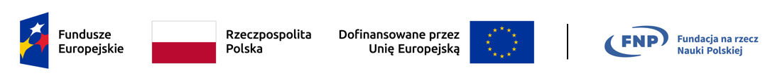
Special recruitment to the Wrocław Doctoral School
of Institutes of PAS - 2024/2025.
Results of recruitment to the project ‘Smart luminescent paints sensitive to temperature and pressure changes for advanced applications’

(grant on behalf of the Foundation for Polish Science (FNP) First Team grant. No. FENG.02.02-IP.05-0018/23, with funds from the 2nd Priority of the Program European Funds for Modern Economy 2021-2027 (FENG) in the Department of Biomedical Physicochemistry of the Institute of Low Temperature and Structure Research of Polish Academy of Sciences in Wroclaw.)

Ranking list.
Interview on December 12, 2024.
Place on the list | Candidate  First and last name | Recruitment points awarded
Place on the list | Candidate  First and last name | Achievements to date (documents)  (0 – 5) | Presentation in English  (0 – 5) | Knowledge in discipline  (0 – 10) | Project PI | Total
Place on the list | Candidate  First and last name | 0 – 5 | 0 – 5 | 0 – 10 | 0 - 4 | 0 – 24
1 | Muhammad Haider Saleem | 2.0 | 2.86 | 4.53 | 0.5 | 9.89
The Recruitment Committee for Chemical and Physical Sciences has set the minimum number of points necessary to admit a candidate to the WDS IPAS as 14.4 (60% of points available).
The only Candidate No. 1 obtained a number of recruitment points lower than the minimum, therefore the Commission decided not to admit Mr. Muhammad Haider Saleem to WDS IPAS to this project and considered the competition pending.

